Egyptian Society Viewing Questions

Watch the following video and fill out the table below:
Ancient Egyptian Social Structure Explained
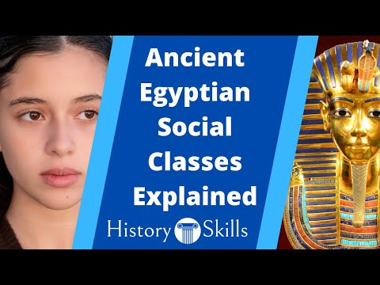

Social Class | What powers, abilities or responsibilities did this social group have?
The Pharaoh

The Vizier

Nomarchs

Priests

Scribes

Nobles

Craftspeople

Farmers

Slaves

Paragraph Writing

Based upon what you learnt in your reading, answer the following question in paragraph format (Topic Sentence, Explanation, Evidence, Concluding Sentence):

Which is the most important social class in Egyptian society?

