Battle of Britain Source Analysis

Step 1: Understanding source analysis
The first thing we need to learn is what ‘source analysis’ means in History. Read the following webpage and answer the questions that follow:
Read: https://www.historyskills.com/source-criticism/analysis/

- What is 'source analysis'?

- What are the six analysis skills used in History?

- What question do we need to answer to understand the perspective of a source?

Step 2: Understanding source perspective
Watch the following video and answer the questions that follow:
How do you determine a source's perspective?
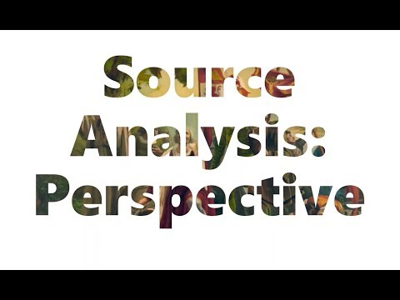

- Perspective, simply put, is...

- If the difference in perspective causes someone to lie or have an unfair view of events or people, that becomes...

- The first step in determining perspective is the know...

- The things you are looking for can include:

- In the first example, Caesar has which kind of perspective?

- In the second example, the photograph has which kind of perspective?

Step 3: Analysis of sources

Using the sources provided, answer the following questions:

Source 1

- According to Source 1, what was the Luftwaffe?

- According to Source 1, when did the ‘Battle of Britain’ begin and end?

- According to Source 1, what two aircraft did the British air force use to cause heavy losses to the Luftwaffe?

- What is the origin of Source 1?

- From what perspective is Source 1 created?

Source 2

- According to Source 2, what was the ‘Blitz’?

- According to Source 2, what was the impact of the bombings on London?

- Is Source 2 a primary or secondary source? How do you know?

- What type of source is Source 2?

- From what perspective is Source 2 created?

Paragraph Writing
Based upon what you have learnt in your source analysis, answer the question below in paragraph format (Topic Sentence, Explanation, Evidence, Concluding Sentence):

What damage did the German air force cause during the Battle of Britain?

In your response, use direct quotes and in-text referencing from the source above.

